 Name: …………….......……

Mathematics Methods, Year 12, 2016

Test 2 – Further differentiation and applications, Integrals

|  |  |  |
| --- | --- | --- |
| **Total** | **/25** | **%** |

30 minutes working time.

Calculator Assumed Section (notes allowed)

SCSA Formula sheet and calculators allowed

1. (2 marks)

Consider the function graphed below:

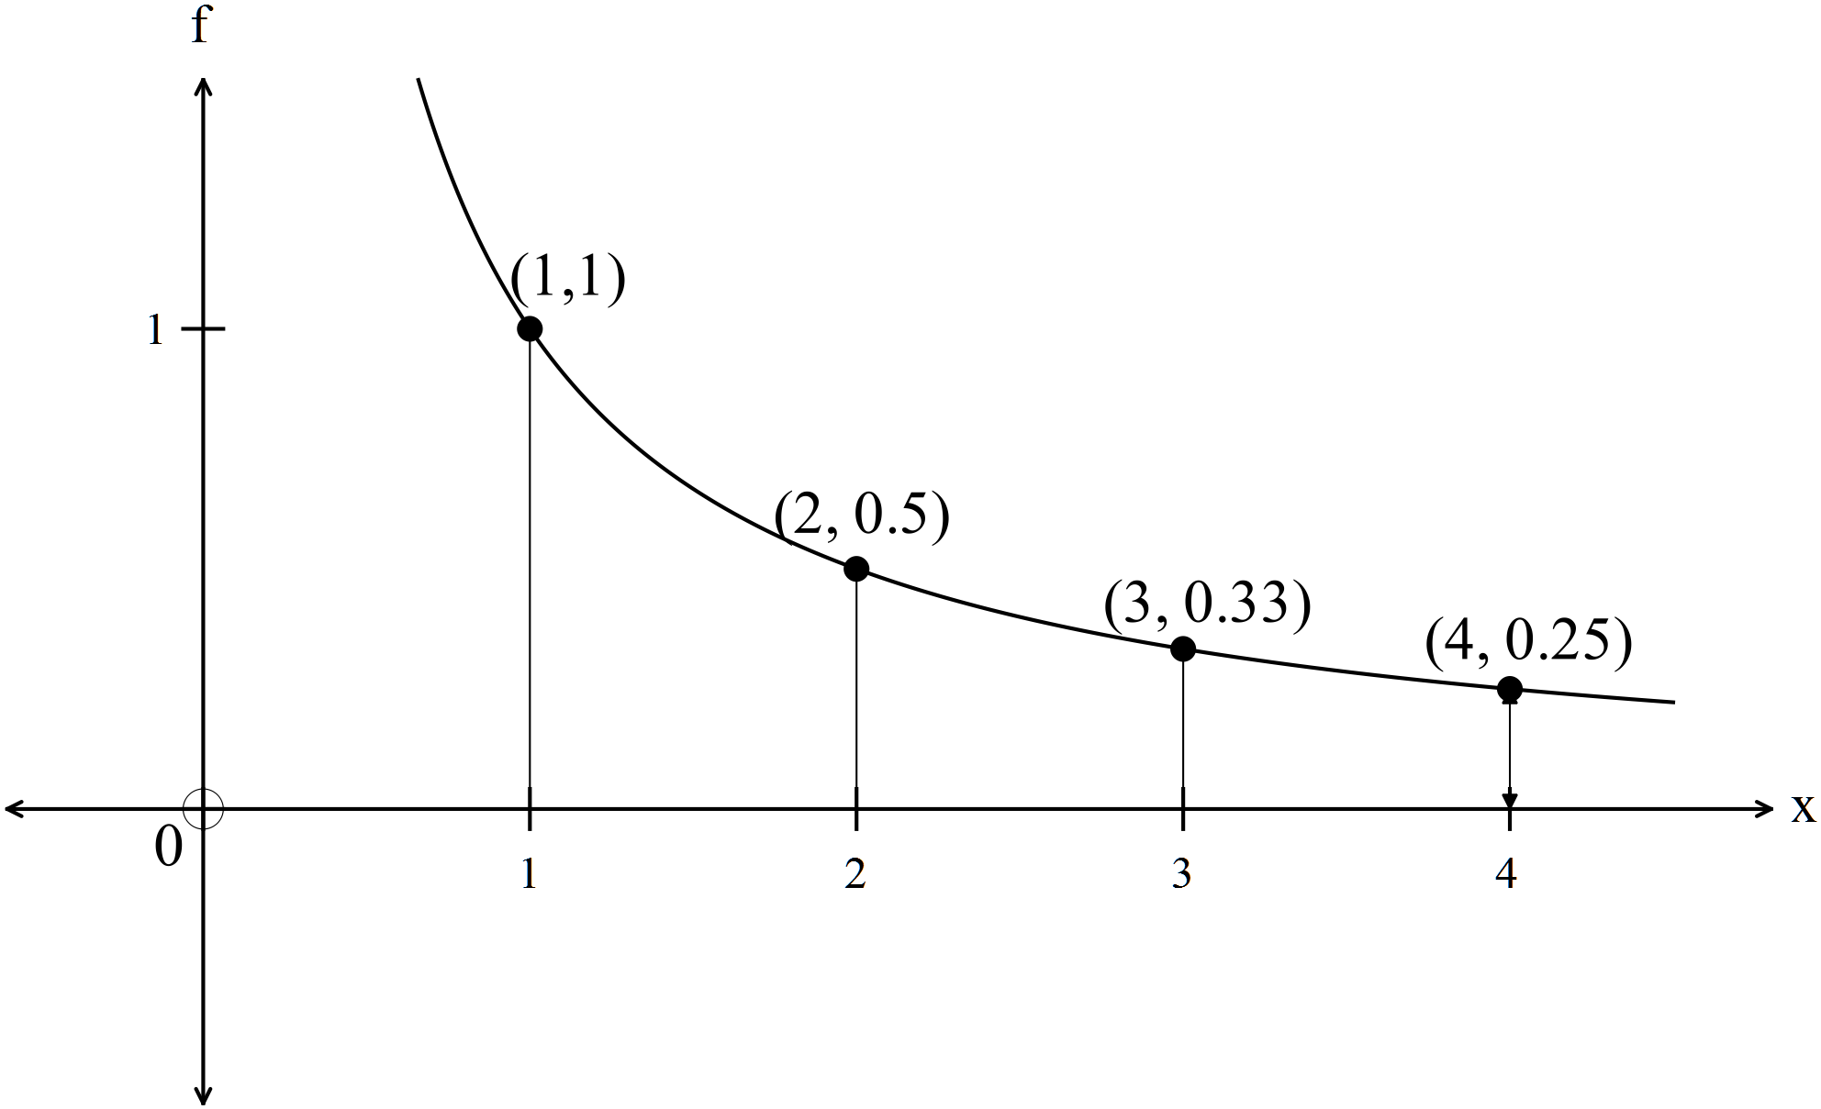

Estimate the area between the function , the  axis and

using rectangles from below and from above.

2. (5 marks)

The graph of  is given below for .

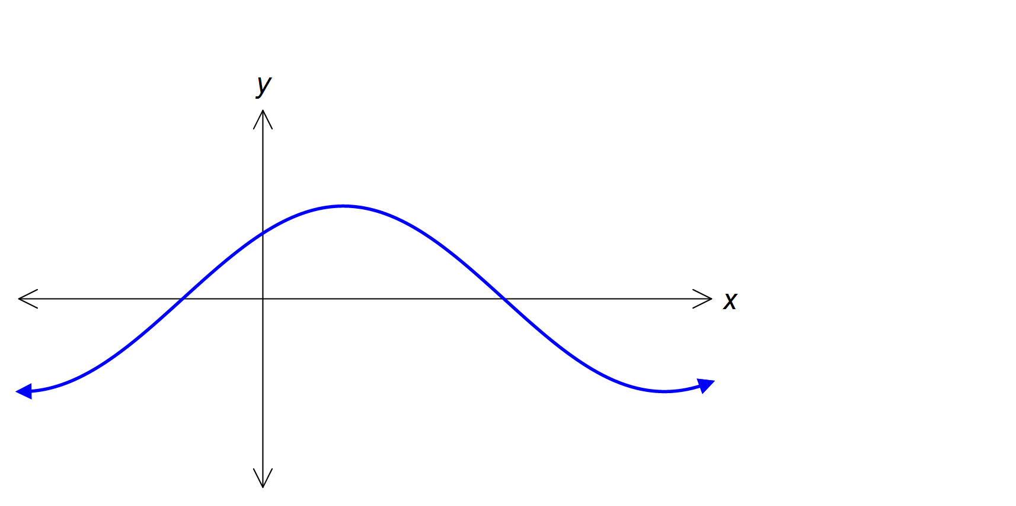

1. Determine the roots of the function  for . (2)
2. Calculate the exact value for area under the curve between the two roots.

(3)

3. (3 marks)

Given 

(a) find  (1)

(b) hence find  given  (2)

4. (6 marks)

Fuel was observed to leak from a damaged tank at a rate of . litres per minute, where  is the number of minutes that have elapsed since the tank was ruptured.

1. How much fuel leaked from the tank during the first two minutes? (to 2 decimal places) (2)

1. If the tank initially contained 400 litres of fuel, determine the time taken, to the nearest second, for the tank to empty. (4)

5. (9 marks)

The velocity of a body is  and the initial displacement is 

Assume 

(a) Find the expression for the displacement. (2)

(b) Find the expression for the acceleration. (1)

(c) Find the second time when the displacement is equal to the initial displacement.

(2)

(d) Find the displacement when the body changes direction. (2)

(e) How far does the body travel in the first second after the body changes

direction? (2)

**END OF TEST**